**Assignment – 4**

**Write a small introduction on types of wired and wireless networks.**

**Wired network :**

Wired networks use physical cables to connect devices and transmit data, such as Ethernet and fiber optic cables. They are often used in offices or where devices are likely to stay in one place due to the fixed nature of the cabling.

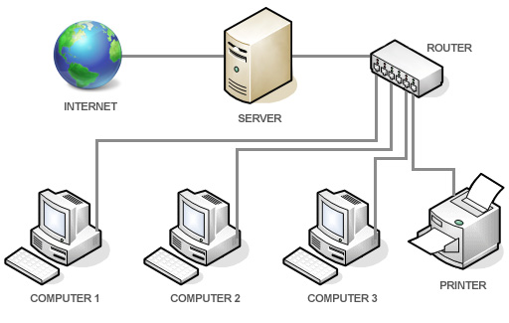

Wired networks utilize physical cables to transmit data, and the main types are based on the cable structure and transmission medium. These include twisted pair, coaxial, and fiber optic cables.

1. Twisted pair cable:

Two or more pairs of wires twisted together. The twisting helps reduce interference.

1. Coaxial cable:Two or more pairs of wires twisted together. The twisting helps reduce interference.
2. Fiber cable:

Uses light pulses to transmit data through thin glass or plastic fibers.

**wireless network:**

A wireless network is a computer network that connects devices using radio waves instead of physical cables. This allows for flexibility and mobility, as devices can stay connected while moving around within the network's coverage area. Examples include Wi-Fi networks used in homes and businesses.

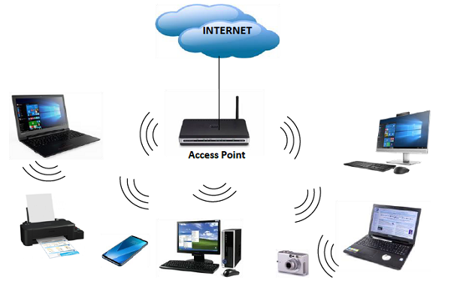

Types of Wireless Network:

1. Wireless LAN (WLAN):

Connects devices within a limited area, like a home or office, using technologies like Wi-Fi.

2.  Wireless Personal Area Network (WPAN):

Connects devices in a very small area, typically within a few meters of a person, using technologies like Bluetooth.

3. Wireless Metropolitan Area Network (WMAN):Connects devices across a larger area, like a city or a metropolitan area, using technologies like WiMAX.